Title: Concise and informative in less than 20 words
Running title: no longer than 80 characters
Abstract
The abstract should be up to 250 words in a structured format consisting of Introduction/Background, Methods, Results and Conclusion briefly specifying the aims of the work, the main results obtained, and the conclusions drawn. Citations must not be included in the abstract.

Keywords: A list of 3 to 5 keywords should be provided, indicating the main subject matter of the manuscript. Keywords should be according to the terms used in the MeSH (Medical Subject Headings) of the Index Medicus/Medline.

Introduction
Introduction should describe the background of the work and its aims. It should neither review the subject extensively nor should it have data or conclusions of the study.
Material and methods
This section should provide sufficient details to allow the work and results to be reproduced. New methods and protocols should be described in detail while well-established and published methods can be briefly described and appropriately cited. The name and details of any material, reagent, equipment and software used should be provided. Ethics: Research involving human participants, human material, or human data, must have been performed in accordance with the Declaration of Helsinki. Authors should include a statement that confirms that the study was reviewed and approved by the appropriate institutional and/or national research ethics committee, including the name of the ethics committee and the reference number where appropriate. Please replace the institution name or any other information showing the identity of authors with “details omitted for double-blind reviewing”. Ethics approval information should be stated completely in the title page. Quality guidelines: Reports of randomized clinical trials should be according to CONSORT guidelines and must include a section entitled "Randomization and masking" within the methods section. Observational research including cohort, case-control, and cross-sectional studies should be reported according to the STROBE recommendations.
Subsection
Only one level of subsection is allowed under the “Material and methods” section.
Results
The results obtained in the study should be presented clearly in the form of text accompanied with appropriate figures and/or tables. Interpretation of the results should be saved for the discussion section. All figures and tables should be referred to in the text, and numbered consecutively. For preparing figures and tables, please follow the formatting instructions provided in the Journal’s Guide for Authors.
Subsection
Only one level of subsection is allowed under the “Results” section.
Discussion
This part should explore the significance of the results of the work, highlighting any trends or points of interest. Avoid repetitive explanation of results, extensive citations and discussion of published literature.
Conclusion
Conclusion should restate the original research question and hypothesis and provide a brief explanation of the significance and implications of the study. It must be fully supported by the study results, rather than a broad statement with no strong evidence.

References
The references should be arranged according to the alphabetical order by the first authors’ last name, as presented in examples below.
Examples of journal references
Delwing-de Lima D, Ulbricht ASSF, Werlang-Coelho C, Delwing-Dal Magro D, Joaquim VHA, Salamaia EM, et al. Effects of two aerobic exercise training protocols on parameters of oxidative stress in the blood and liver of obese rats. J Physiol Sci 2018; 68: 699-706. https://doi.org/10.1007/s12576-017-0584-2
Greenberg AS, Obin MS. Obesity and the role of adipose tissue in inflammation and metabolism. Am J Clin Nutr 2006; 83: 461-5. https://doi.org/10.1093/ajcn/83.2.461S
Examples of book references
Norman IJ, Redfem S, editors. Mental health care for elderly people. New York: Churchill Livingstone, 1996, p. 200-16.
Phillips SJ, Whisnant JP. Hypertension and stroke. In: Laragh JH, Brenner BM, editors. Hypertension: pathophysiology, diagnosis, and management. 2nd ed. New York: Raven Press, 1995, p. 465-78.
Citation in the text
Citation in the text (Lawrence, 2002; Mirzaii et al., 2020). Citation in the text (Boron and Boulpaep, 2012). Citation in the text (Johnson, 2003).

Figure legends
Figure 1. Each figure legend, up to 300 words, should include a brief title sentence for the whole figure and a short description for each part. Methodological details should be kept minimum as much as possible.
Figure 2. Each figure legend, up to 300 words, should include a brief title sentence for the whole figure and a short description for each part. Methodological details should be kept minimum as much as possible.

Place each figure on separate pages.

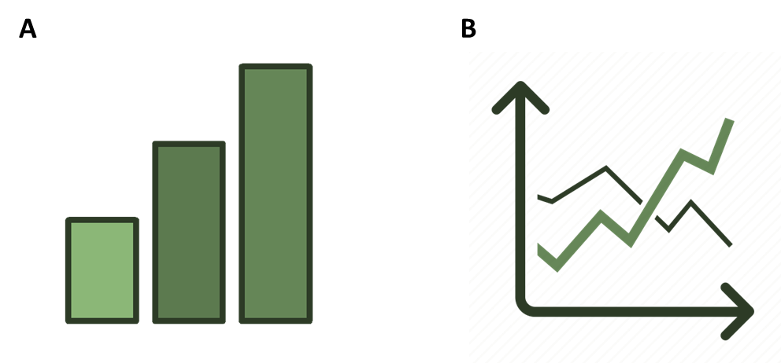

Figure 1.

Figure 2.

Table 1. Place table caption above
Notes below the table body.

Table 2. Place table caption above
Notes below the table body.

