Title: Concise and informative in less than 20 words
Running title: no longer than 80 characters
Abstract
The abstract should be up to 250 words, not be divided into sections (unstructured format) briefly specifying the aims of the work, the types of literature used in the review, and the conclusions drawn. Citations must not be included in the abstract

Keywords: A list of 3 to 5 keywords should be provided, indicating the main subject matter of the manuscript. Keywords should be according to the terms used in the MeSH (Medical Subject Headings) of the Index Medicus/Medline.

Introduction
Full-length review articles is recommended to be structured in introduction, main sections (according to the topic) and one level of subsections under each section, and conclusion. Review articles are encouraged to contain figures, tables, summary diagrams and illustrations of the proposed concept. Mini-reviews should have a maximum word count of 3500, and may contain no more than 2 tables/figures. Quality guidelines: Reports of the systematic reviews and meta-analyses must be according to PRISMA guidelines.
Section title
Full-length review articles is recommended to be structured in introduction, main sections (according to the topic) and one level of subsections under each section, and conclusion. Review articles are encouraged to contain figures, tables, summary diagrams and illustrations of the proposed concept.
Subsection
Preferably, one level of subsection is recommended under the each section.
Conclusion
Conclusion should provide a brief explanation of the significance and implications of the study.

References
The number of references should be kept to a minimum. For mini-reviews, a maximum of 40 references would be acceptable. The references should be arranged according to the alphabetical order by the first authors’ last name, as presented in examples below.
Examples of journal references
Delwing-de Lima D, Ulbricht ASSF, Werlang-Coelho C, Delwing-Dal Magro D, Joaquim VHA, Salamaia EM, et al. Effects of two aerobic exercise training protocols on parameters of oxidative stress in the blood and liver of obese rats. J Physiol Sci 2018; 68: 699-706. https://doi.org/10.1007/s12576-017-0584-2
Greenberg AS, Obin MS. Obesity and the role of adipose tissue in inflammation and metabolism. Am J Clin Nutr 2006; 83: 461-5. https://doi.org/10.1093/ajcn/83.2.461S
Examples of book references
Norman IJ, Redfem S, editors. Mental health care for elderly people. New York: Churchill Livingstone, 1996, p. 200-16.
Phillips SJ, Whisnant JP. Hypertension and stroke. In: Laragh JH, Brenner BM, editors. Hypertension: pathophysiology, diagnosis, and management. 2nd ed. New York: Raven Press, 1995, p. 465-78.
Citation in the text
Citation in the text (Lawrence, 2002; Mirzaii et al., 2020). Citation in the text (Boron and Boulpaep, 2012). Citation in the text (Johnson, 2003).

Figure legends
Figure 1. Each figure legend, up to 300 words, should include a brief title sentence for the whole figure and a short description for each part. Methodological details should be kept minimum as much as possible.
Figure 2. Each figure legend, up to 300 words, should include a brief title sentence for the whole figure and a short description for each part. Methodological details should be kept minimum as much as possible.

Place each figure on separate pages.

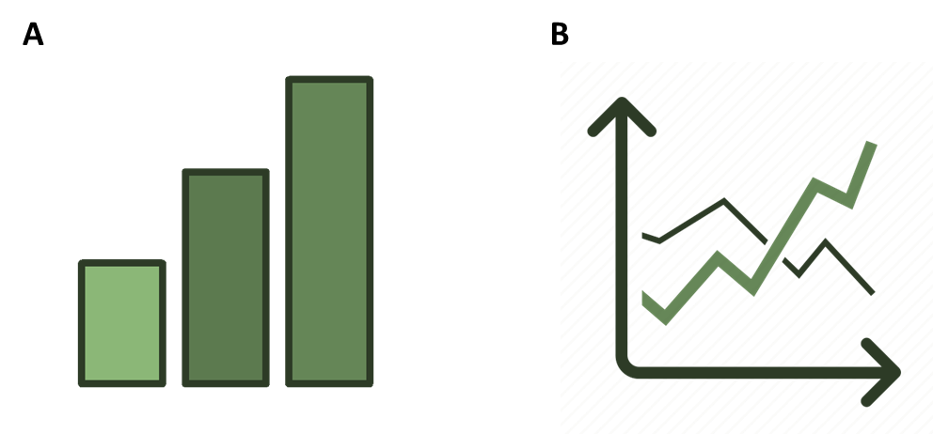

Figure 1.

Figure 2.

Table 1. Place table caption above
Notes below the table body.

Table 2. Place table caption above
Notes below the table body.

